

REGISTRATION NUMBER:- 25BSA10037
NAME:- Ayushi
BRANCH – BTECH In Cse Cloud computing
and automation

Hair care Test

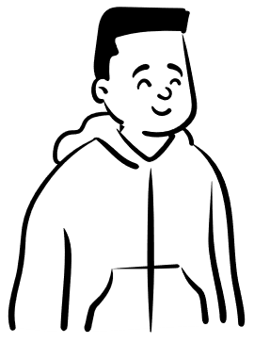
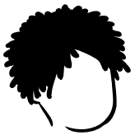

Table of content
S.no | title
1 | introduction
2 | Problem statements
3 | Functional and non-functional requirements
4 | System architecture
5 | Design diagrams
6 | Design decision
7 | Implementation details
8 | Screenshots/results
9 | Testing approach
10 | Challenges faced
11 | Learnings
12 | Future enhancements
13 | references

INTRODUCTION
- Many people are dealing with a lot of stress which can be one the reason for hairloss
- Key features of the project
- it informs you about the hair chemicals you should avoid for less breakage
- it tells you about chemicals that would suit you
- it also suggests the brand that have products based on chemicals that would suit you

In today’s world, the abundance of skincare and health care products can often be overwhelming, making it difficult for individuals to select the right products suited to their unique skin and health needs. Each person’s skin and body type is different, and with a variety of conditions ranging from acne and dry skin to sensitive skin or aging concerns, a one-size-fits-all approach is not always effective.
This project aims to provide a tailored solution by helping individuals choose the most appropriate skin and health care products based on their specific needs. Through an in-depth analysis of common skin and health concerns, this project will offer personalized recommendations, ensuring that users can confidently select products that will benefit them the most. By understanding the underlying causes of different skin issues and health conditions, we seek to optimize product effectiveness, improve health outcomes, and help individuals maintain their well-being with products suited to their unique profiles



Python is a high-level language. It is a free and open-
source language.
❖ It is an interpreted language, as Python programs are
executed by an interpreter.
❖ Python programs are easy to understand as they have a
clearly defined syntax and relatively simple structure.
Python is case-sensitive. For example, NUMBER and
number is not same in Python.
❖ Python is portable and platform independent, means it
can run on various operating systems and hardware
platforms.
❖ Python has a rich library of predefined functions.
❖ Python is also helpful in web development. Many popular
web services and applications are built using Python
❖ Python uses indentation for blocks and nested blocks.

PROBLEM STATEMENT
Create a python program that helps the user to choose a suitable hair care ingredient as well as the hair care product based on their specific hair conditions or hair concerns

Solution:

The program should go like:-

Storing predefined data for the hair conditions as well as the ingredients
Accept the input from the user based on their hair condition
Process the input accordingly
Display the results

FUNCTIONAL REQUIREMENTS

1. Input Handling
The system shall prompt the user to enter one or more hair conditions separated by commas.
The system shall convert the user input to lowercase to ensure consistent matching.
The system shall parse the input into a list of individual hair conditions.

2. Data Lookup
The system shall store predefined data for each supported hair condition, including:
Recommended ("good") ingredients
Ingredients to avoid ("bad")
Recommended product brands

The system shall verify whether each user-entered condition exists in the predefined data.
The system shall identify any unsupported or invalid conditions.

3. Recommendation Aggregation
For each valid condition, the system shall collect:
Good ingredients
Bad ingredients
Recommended brands
The system shall merge the results across multiple conditions using sets to avoid duplicates.
The system shall maintain separate combined sets for good ingredients, bad ingredients, and brands.

4. Output Generation
The system shall display all recommended ingredients aggregated from valid conditions.
The system shall display all ingredients to avoid aggregated from valid conditions.
The system shall display all recommended product brands aggregated from valid conditions.
The system shall display a message listing any invalid or unsupported conditions entered.
The system shall suggest valid options when invalid conditions are found.

5. Program Behaviour
The program shall not crash when given unexpected or invalid input.
The program shall allow users to input multiple conditions at once.
The program shall prevent duplicate entries in the output through the use of sets.

NON-FUNCTIONAL REQUIREMENTS
1. Usability
The program shall provide clear and readable text output.
The program shall display instructions and results in an easy-to-understand format.
The system shall be simple enough for users with no technical background.

2. Performance
The program shall process user input and generate recommendations in under one second.
The program shall efficiently handle multiple conditions without noticeable delay.

3. Reliability
The system shall handle unexpected or invalid input without crashing.
The program shall consistently produce the same output for the same input.
The program shall ensure the predefined dataset remains consistent and accessible throughout execution.

4. Maintainability
The code shall be structured in a way that allows easy updates to the hair-condition data.
The program shall use clear variable names and logical organization for ease of future modification.
The system shall allow adding new hair conditions or modifying existing ones without requiring major code changes.

5. Portability
The program shall be executable on any system that supports Python (Windows, macOS, Linux).
The program shall not rely on external libraries beyond Python’s standard library.

6. Scalability
The program shall allow expansion of hair-condition categories without loss of performance.
The system shall handle larger datasets (more ingredients or brands) without requiring structural changes.

7. Security
The program shall not collect, store, or transmit any personal user data.
The system shall avoid using any insecure external dependencies.

8. Accessibility
The program’s text output shall be readable for users with basic visual limitations (e.g., adequate spacing, clear layout).
The program shall not require mouse interaction and must be fully operable through keyboard input

SYSTEM ARCHITECTURE
1. Overview
The system follows a three-layer architecture:
Presentation Layer (User Interaction Layer)
Application Logic Layer (Processing Layer)
Data Layer (Storage Layer)
This structure ensures clarity, maintainability, and easy future expansion.

2. Architectural Diagram (Conceptual)
+------------------------------------------------------+
| Presentation Layer |
| (Input / Output Interface) |
+------------------------+-----------------------------+
|
v
+------------------------------------------------------+
| Application Logic Layer |
| - Input Parsing |
| - Condition Validation |
| - Recommendation Aggregation |
| - Error Handling |
+------------------------+-----------------------------+
|
v
+------------------------------------------------------+
| Data Layer |
| - Predefined Hair Condition Database (Dictionary) |
| - Ingredients, bad ingredients, brands |
+------------------------------------------------------+
3. Layer Descriptions

A. Presentation Layer

Responsibilities:
Prompt the user for input.
Display recommendations, warnings, or error messages.
Provide readable output formatting.

Components:
input() function
print() statements

B. Application Logic Layer

Responsibilities:
Convert user input to lowercase and split into a list.
Validate each hair condition.
Aggregate data across multiple conditions.
Maintain sets to avoid duplicate results.
Generate final structured output for display.

Key Operations:

Parsing module
Validation module
Deduplication logic
Result assembly

C. Data Layer

Responsibilities:
Store all predefined hair-condition data.
Provide fast lookup for ingredients and brands.

Components:
hair_ingredients dictionary containing:
good ingredients
bad ingredients
recommended brands

Characteristics:
1.Static, read-only during program execution
2.Easily extendable (new conditions, ingredients, brands)

4. Data Flow Explanation
User enters hair conditions → sent to the Application Logic Layer
Logic layer parses and validates conditions
Logic layer queries Data Layer for matching values
Logic layer aggregates and deduplicates all results
Output is sent back to the Presentation Layer
Presentation Layer displays results to the user

5. Architectural Benefits
Modularity: Layers separate the UI, logic, and data.
Maintainability: Easy to update data without changing logic.
Reusability: Logic can be reused with a GUI or web version later.
Scalability: New hair conditions can be added easily.
Clarity: Code is easier to understand and modify

DESIGN DIAGRAMS
USE CASE DIAGRAM
+-------------------+
| User |
+---------+---------+
|
v
+---------------------------+
| Hair Recommendation System |
+---------------------------+
/ | | \
v v v v
(Enter Hair) (Validate) (Retrieve) (Display)
(Conditions) (Conditions) (Data) (Results)

WORK FLOW
┌─────────────────────┐
│ Start Program │
└──────────┬──────────┘
v
┌────────────────────────────────┐
│ Prompt user for hair condition │
└──────────┬────────────────────┘
v
┌────────────────────────────────┐
│ Parse input into condition list │
└──────────┬────────────────────┘
v
┌───────────────────────────────────────┐
│ For each condition: │
│ - If valid → collect data │
│ - Else → add to invalid list │
└──────────┬────────────────────────────┘
v
┌──────────────────────────────────────────┐
│ Display combined good ingredients │
└──────────┬───────────────────────────────┘
v
┌──────────────────────────────────────────┐
│ Display ingredients to avoid │
└──────────┬───────────────────────────────┘
v
┌──────────────────────────────────────────┐
│ Display recommended brands │
└──────────┬───────────────────────────────┘
v
┌──────────────────────────────────────────┐
│ If invalid conditions → show suggestions │
└──────────┬───────────────────────────────┘
v
┌──────────────┐
│ End │
└──────────────┘
SEQUENCE
User Program Data Store (hair_ingredients)
| | |
|---enter input---->| |
| | |
| |---parse input---------->|
| |<------------------------|
| |
| |---validate conditions-->|(checks dictionary)
| |<------------------------|
| |
| |---retrieve good/bad/brands--->|
| |<------------------------------|
| |
|<---display results-------------------------------|
CLASS/COMPONENT DIAGRAM
+-------------------------------------------+
| HairSystem |
+-------------------------------------------+
| - hair_ingredients: dict |
+-------------------------------------------+
| + get_good(cond): list |
| + get_bad(cond): list |
| + get_brands(cond): list |
| + is_valid(cond): bool |
+-------------------------------------------+

(uses)
|
v

+-------------------------------------------+
| User Interface |
+-------------------------------------------+
| + prompt_user(): string |
| + display_results(): void |
+-------------------------------------------+
ER DAIGRAM

+-------------------+
| HairCondition |
|-------------------|
| condition_name PK |
+---------+---------+
| 1
/ \
/ \
/ \ M
+------+ +------+
| |
v v

+-------------------+ +--------------------+
| GoodIngredient | | BadIngredient |
|-------------------| |--------------------|
| ingredient_name PK| | ingredient_name PK |
+-------------------+ +--------------------+

(1-to-M relationships)

+----------------------+
| Brand |
|----------------------|
| brand_name PK |
+----------------------+

DESIGN DECISION & RATIONALE

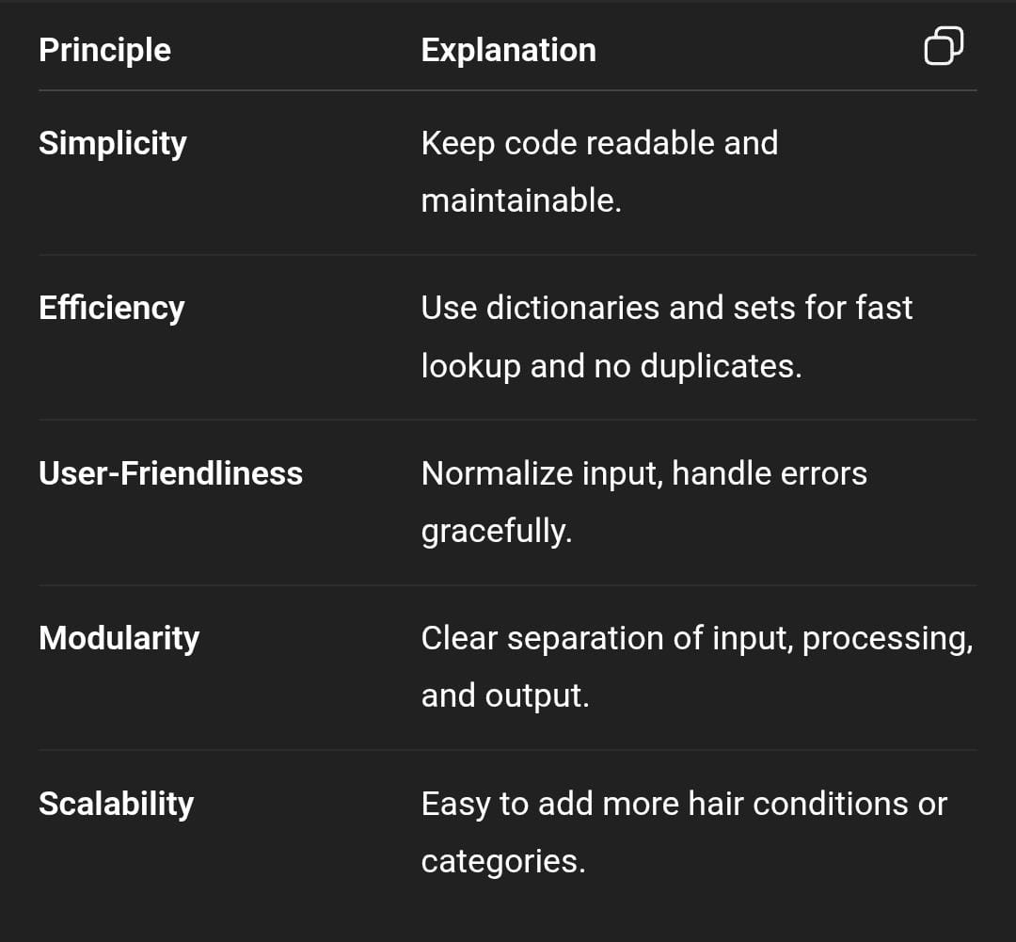

IMPLEMENTATION DETAILS
1. Data Structure: hair_ingredients
A nested Python dictionary mapping hair conditions to three lists:
good → beneficial ingredients
bad → ingredients to avoid
brands → recommended product brands
Example Structure
hair_ingredients = {
"dry": {
"good": [...],
"bad": [...],
"brands": [...]
},
...
}
Why this structure?
Easy lookups: hair_ingredients[condition]["good"]
Extensible: adding new conditions or new fields (e.g., “notes”, “products”) is trivial
Readable: keys describe exactly what they contain
Works naturally with user input conditions

2. User Input Handling
user_input = input("Enter your hair condition(s)...").lower()
conditions = [c.strip() for c in user_input.split(",")]
What this does
Converts input to lowercase → ensures case-insensitive matching

Splits on commas → supports multiple conditions: "dry, frizzy"
Strips whitespace → " dry " becomes "dry"
Key Benefit:-
Makes input processing robust and user-friendly.

3. Aggregation Logic
Combined Sets
combined_good = set()
combined_bad = set()
combined_brands = set()
invalid_conditions = []
Why use sets?
Avoids duplicates (e.g., “Argan Oil” appears in both dry and frizzy)
Output order does not matter initially,Eliminates need for manual deduplication

Aggregation Loop
for cond in conditions:
if cond in hair_ingredients:
combined_good.update(hair_ingredients[cond]["good"])
combined_bad.update(hair_ingredients[cond]["bad"])
combined_brands.update(hair_ingredients[cond]["brands"])
else:
invalid_conditions.append(cond)
Explanation
Checks if each user-provided condition exists in the dataset

If yes: merges the lists into the sets
If no: records the invalid input for display
Behavior Example
If user enters "frizzy, damaged":
All good ingredients for both conditions appear
No duplicates
Same for bad ingredients and brands

4. Output Formatting
Outputs are displayed only if non-empty:
if combined_good:
print("\nRecommended Ingredients for your hair:")
for ing in sorted(combined_good):
print(f"- {ing}")
Why sorting?
Makes the output predictable & readable
Ensures consistency even when sets reorder elements

Output Sections
Recommended ingredients
Ingredients to avoid
Recommended brands
Unknown/invalid conditions
Example output (formatted):
Recommended Ingredients for your hair:
- Argan Oil
- Coconut Oil
- Dimethicone

Ingredients to Avoid:
- Strong Sulfates
- Drying Alcohols

Recommended Hair Product Brands:
- John Frieda Frizz Ease
- Keratin Complex
5. Error Handling
if invalid_conditions:
print("No data available for:", ", ".join(invalid_conditions))
Purpose
Notifies user if they typed something unsupported

Provides list of valid options

Example
Input:dry, superoily
Output:No data available for: superoily
Try: dry, frizzy, oily, dandruff, damaged

SCREEN SHORTS/ RESULTS

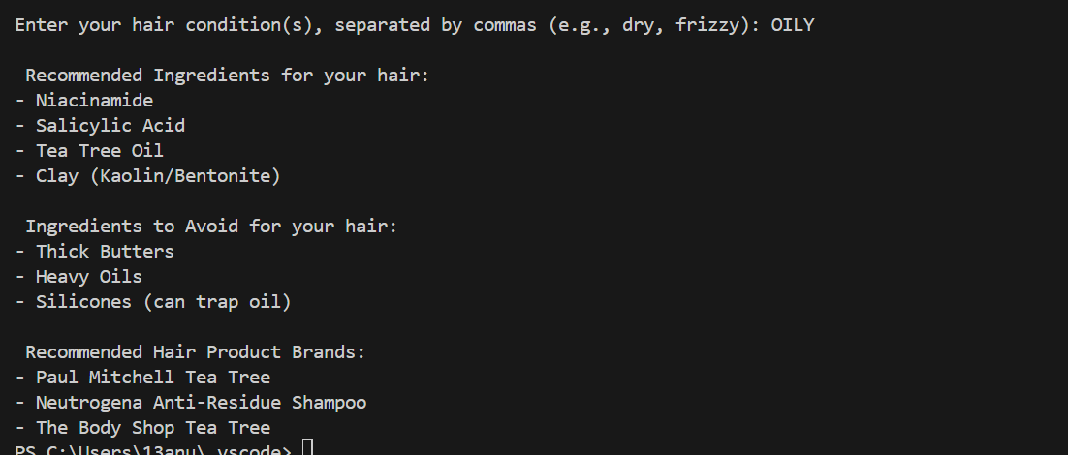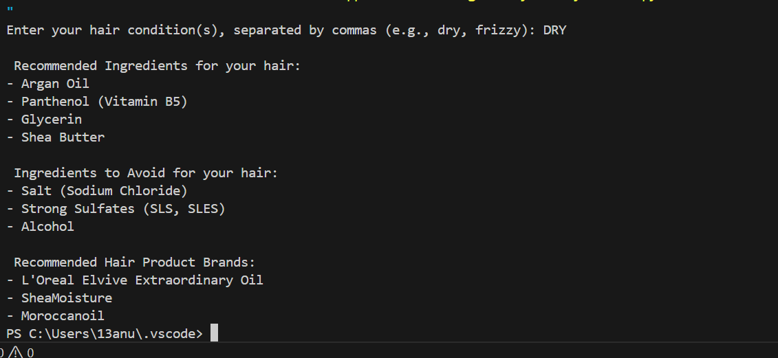

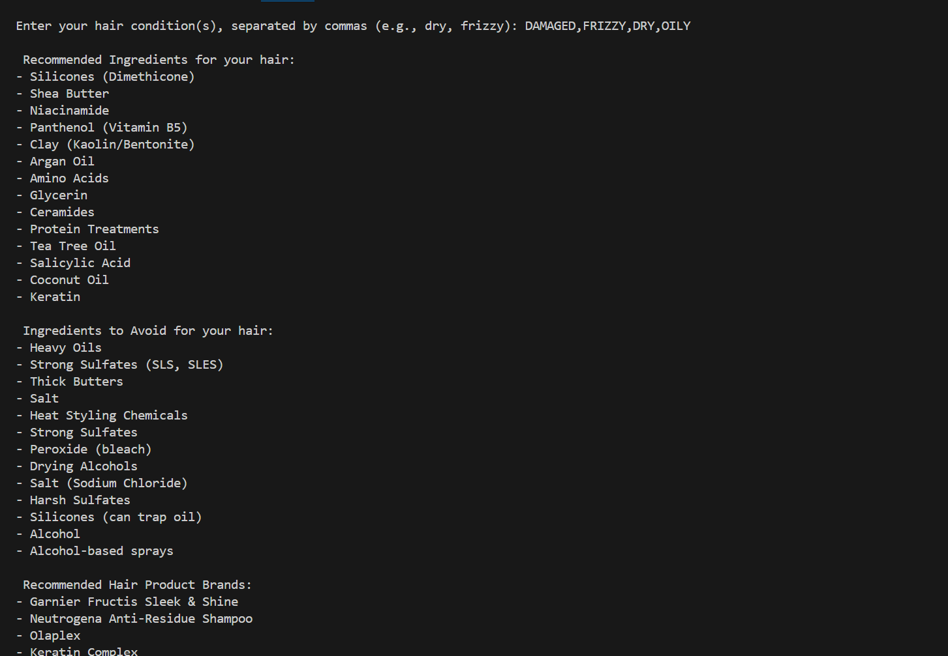
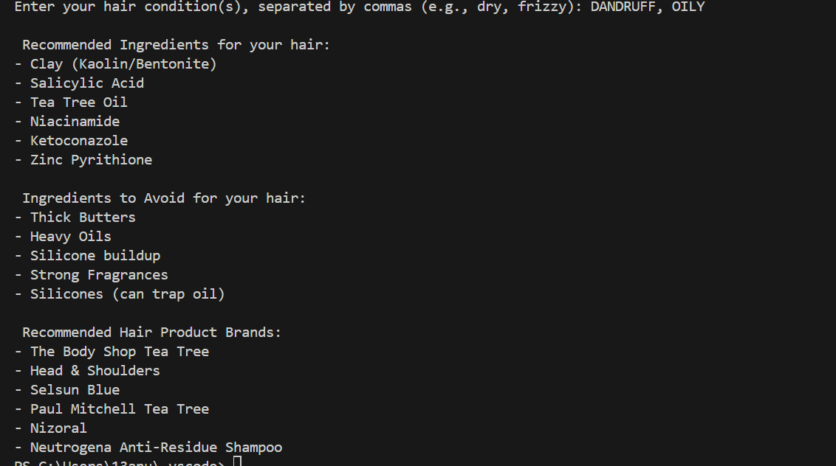

TESTING APPROCH
1. Test Strategy
The goal is to verify that:
- The program correctly interprets user input
- Aggregation of ingredients/brands is accurate
- Invalid inputs are handled gracefully
- Outputs match expectations (clean, sorted, deduplicated)
- Application remains stable under unusual or extreme input

Testing includes:
- Unit Testing
- Functional Testing
- Input Validation Testing
- Boundary & Edge Case Testing

A. Unit Testing
Focus on individual components:
- Parsing input
- Condition validation
- Aggregation of ingredients
- Deduplication
- Sorting
(These can be written using pytest.)

B. Functional & Integration Testing
- Test the script end-to-end:
- User enters input
- Logic executes
- Output formatting is correct
- Simulate terminal behavior using:
- pytest + capsys
- Python’s unittest.mock for input()

C. Input Validation Testing
Check whether:
- Lowercase/uppercase input works
- Whitespace is removed
- Comma-separated values work
- Unknown conditions are reported

D. Edge Case & Negative Testing
- Ensure correct behavior when:
- Input is empty
- Input has only invalid conditions
- Input contains duplicates
- Input is excessively long
- Mixed valid + invalid conditions

CHALLENGES FACED

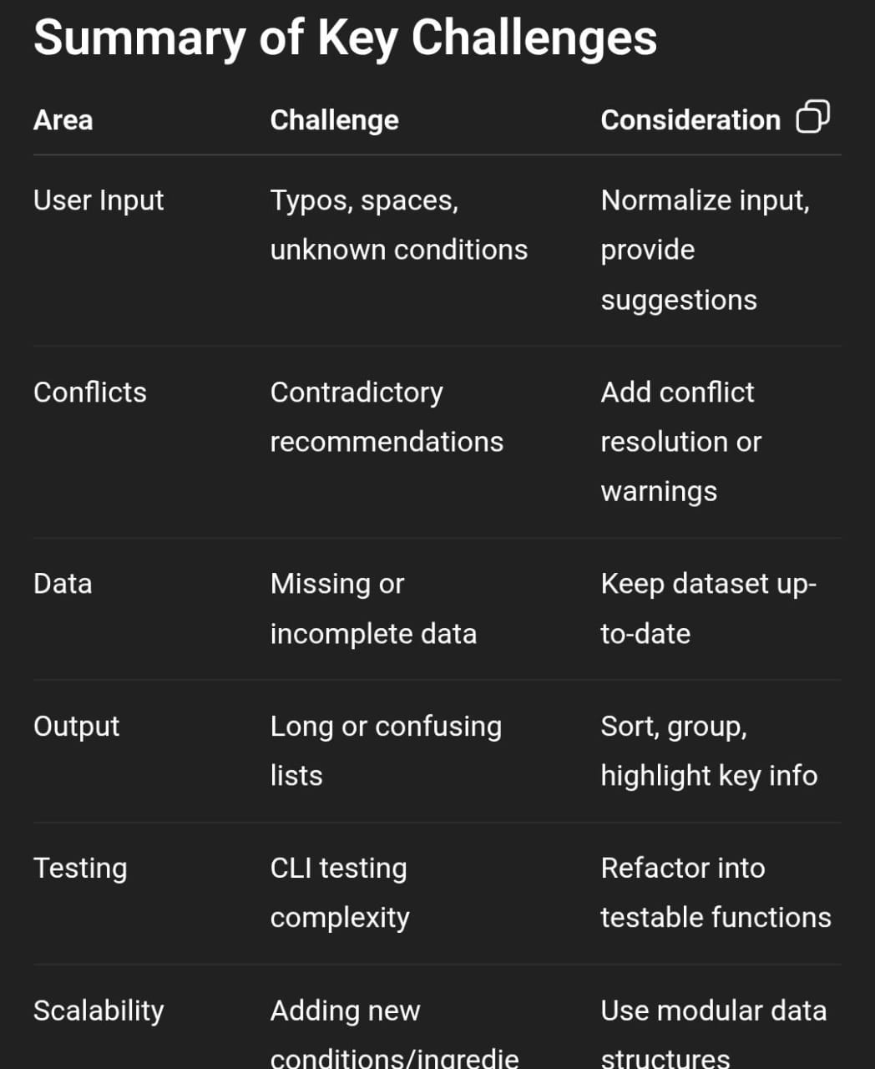

LEARNING AND KEY TAKEAWAYS
1. Technical Learnings
A. Data Structures Matter
Using a nested dictionary with lists made it easy to store, retrieve, and update ingredients and brands .Sets were crucial for deduplication when combining multiple conditions. Sorting sets before output improved readability.

B. Input Handling is Critical
Normalizing user input (lowercasing, stripping whitespace) avoids errors and ensures robustness. Planning for invalid or unexpected input is essential for user-friendly applications.

C. Aggregation Logic
Combining data from multiple sources (conditions) teaches careful merge logic.
Conflict or contradiction handling is a common issue in recommendation systems.

D. Modularization and Testing
Refactoring logic into functions makes unit testing and automation easier.

Testing CLI programs requires strategies like mocking input() and capturing print() outputs.

2. Design & UX Learnings
A. Clear Output Design
Alphabetically sorted lists and section headers greatly improve readability.
Providing warnings for invalid input enhances user experience.

B. Handling Multiple Conditions
Multi-condition aggregation can result in conflicting advice.
Designing for conflict resolution or priority weighting is a key UX and logic takeaway.

C. Dataset Limitations
Real-world recommendation systems need comprehensive and updatable data.
Planning for expansion (more conditions, ingredients, brands) is important.

3. Algorithm & Logic Takeaways
Set operations (update, union) are efficient for merging multiple lists without duplicates.
String normalization is simple but prevents a lot of potential bugs.
Clear separation of data, logic, and output makes debugging much easier.

4. Testing & Quality Assurance Learnings
Edge cases like empty input, unknown conditions, or repeated entries must be handled explicitly.
Writing automated tests early ensures reliability and reduces regression errors.
Thinking through conflicts and inconsistencies helps plan for future extensions.

5. General Takeaways
Simplicity first: Start with clear, readable data structures and logic.
Robust input handling: Always anticipate user errors.
Deduplication and sorting: Improve usability with minimal effort.
Extensibility matters: Design for future expansion (new conditions, ingredients, conflicts).
Testing is essential: Both unit and functional tests catch subtle errors early.
Documentation helps: Clear comments, structure, and design notes improve maintainability.

FUTURE ENHANCEMENTS
1. Conflict Resolution & Prioritization
Problem: Multi-condition inputs may contain contradictory ingredient advice (e.g., dry vs oily).

Enhancement:
- Implement priority weighting for ingredients.
- Flag conflicting ingredients to the user.
- Provide recommendation ranking based on condition severity or user preference.

2. Personalized Recommendations
- Ask the user additional details: hair length, color treatment, age, or scalp sensitivity.
- Customize ingredient and brand recommendations based on these personal attributes.
Example: Suggest gentle sulfate-free shampoos for chemically treated hair.

3. Expanded & Dynamic Dataset
- Add more conditions (e.g., thinning hair, curly hair, color-treated hair).
- Include more brands and ingredient alternatives.
- Make dataset dynamic, possibly reading from a CSV, JSON, or database.
- Support user-submitted products with validation.

4. GUI or Web Interface
- Develop a graphical interface using Tkinter, PyQt, or a web app using Flask/FastAPI + React.
- Allow users to select multiple conditions via checkboxes.
- Display results in sections with color coding: good ingredients in green, bad in red.

5. Ingredient Details & Education
- Include short descriptions of each ingredient (benefits, precautions).
- Explain why some ingredients are good or bad for certain conditions.
- Could integrate links to external sources for user education.

6. Save/Export Recommendations
- Allow users to download results as PDF, CSV, or TXT.
- Save previous recommendations for comparison.
- Could integrate user accounts if expanded to a web app.

7. Recommendation Analytics
- Track most recommended ingredients or brands.
- Allow trending analysis: which brands/ingredients users prefer.
- Useful for data-driven improvements.

REFERENCES
In order to work on this project titled –Educational
Technology(EdTech), the following books and
websites are referred by me during the various
phases of development of the project.
1) www.youtube.com
2) www.python.com
OTHER THAN THE MENTIONED THING I HAVE ALSO SEEKED HELP AND INFORMATION FROM MY TEACHERS WHO MADE ME UNDERSTAND EACH AND EVERY DETAIL OF THE PROJECT
Many people are dealing with a lot of stress which can be one the reason for hairloss
Key features of the project
- it informs you about the hair chemicals you should avoid for less breakage
- it tells you about chemicals that would suit you
- it also suggests the brand that have products based on chemicals that would suit you

THANKYOU

